1.7 Centers of Mass Worksheet

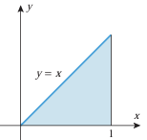
- Determine the centroid of the region shown in the picture on the right.

We start by finding the area of the region.
We calculate that .
Note we could have also just found the area using geometry:.

We then calculate that
And

Therefore, the centroid of the region is .

- Determine the centroid of the region shown in the picture on the right.

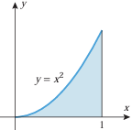
We start by finding the area of the region.
We calculate that .

We then calculate that
And

Therefore, the centroid of the region is .

- Determine the centroid of the region shown in the picture on the right.

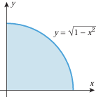
We start by finding the area of the region. If we try to set up this integral it is rather difficult to evaluate .
So instead, we note that we are dealing with the area of a quarter circle and therefore, .

We then calculate that
Let and then .
Our bounds become .
And

Therefore, the centroid of the region is .

